Assignment 6
Problem 1:
Hydraulic System
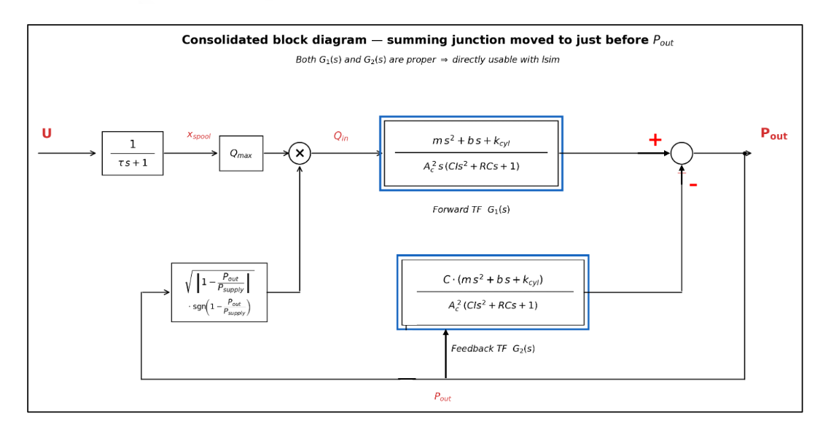

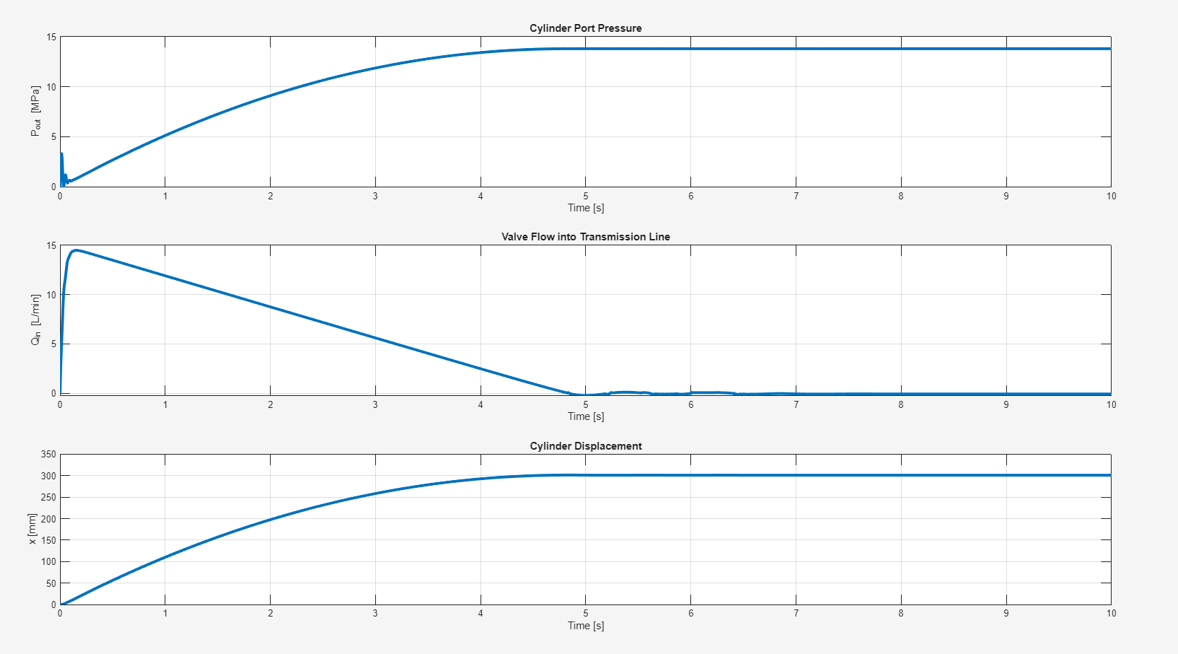

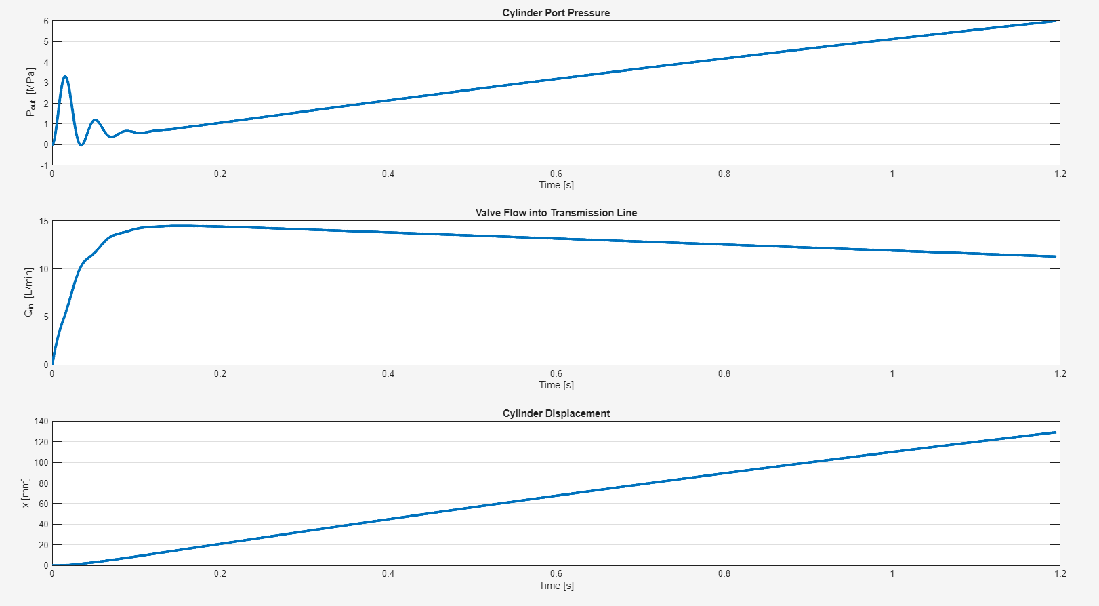

===================================================================
POLE-ZERO ANALYSIS
===================================================================

--- G1(s) Forward TF ---
Index Pole Re(pole) Stability
------ ------------------------------ ---------- ----------
1 0.000000e+00 0.0000e+00 MARGINAL
2 -2.091503e+01 +3.314463e+02i -2.0915e+01 STABLE
3 -2.091503e+01 -3.314463e+02i -2.0915e+01 STABLE

Index Zero
------ ------------------------------
1 -7.500000e-01 +8.627717e+00i
2 -7.500000e-01 -8.627717e+00i

--- G2(s) Feedback TF ---
Index Pole Re(pole) Stability
------ ------------------------------ ---------- ----------
1 -2.091503e+01 +3.314463e+02i -2.0915e+01 STABLE
2 -2.091503e+01 -3.314463e+02i -2.0915e+01 STABLE

Index Zero
------ ------------------------------
1 -7.500000e-01 +8.627717e+00i
2 -7.500000e-01 -8.627717e+00i

Problem 2:
Problem Parameters
------------------
Motor Power P_motor = 2000 W
Motor Efficiency eta_motor = 0.94
Required Heat Removal q_Required = 120.00 W [= (1 - eta) * P_motor]
Base Temperature T_b = 80.0 C
Ambient Temperature T_inf = 20.0 C
Temperature Difference T_b-T_inf = 60.0 C
Convection Coeff h = 10.00 W/m^2K
Fin Conductivity k_fin = 200.0 W/mK
Fin Width (motor axis) w = 0.1500 m (5.9055 in)
Motor Diameter D = 0.1500 m (5.9055 in)
Motor Circumference Pmax = 0.4712 m (18.5527 in)
Min Fin Spacing smin = 0.0080 m (0.3150 in)
Thickness Range t_range = [0.0020 : 0.0150] m
Length Range L_range = [0.0050 : 0.0250] m
Total Feasible Designs = 98
Maximum q_fin (feasible designs) = 4.7894 W

========================================================================
TOP 10 DESIGNS - Ranked by Descending q_fin
========================================================================
Rank t[m] t[in] L[m] L[in] N_fins %Perim eta_f% Space[m] q_fin[W]
------------------------------------------------------------------------------
1 0.0100 0.3937 0.0250 0.9843 26 55.17 99.78 0.0081 4.7894
2 0.0095 0.3740 0.0250 0.9843 26 52.42 99.77 0.0086 4.7739
3 0.0090 0.3543 0.0250 0.9843 26 49.66 99.76 0.0091 4.7583
4 0.0085 0.3346 0.0250 0.9843 26 46.90 99.74 0.0096 4.7427
5 0.0080 0.3150 0.0250 0.9843 26 44.14 99.73 0.0101 4.7270
6 0.0075 0.2953 0.0250 0.9843 26 41.38 99.71 0.0106 4.7113
7 0.0070 0.2756 0.0250 0.9843 26 38.62 99.69 0.0111 4.6954
8 0.0065 0.2559 0.0250 0.9843 26 35.86 99.67 0.0116 4.6794
9 0.0060 0.2362 0.0250 0.9843 26 33.10 99.64 0.0121 4.6632
10 0.0055 0.2165 0.0250 0.9843 26 30.35 99.61 0.0126 4.6468

========================================================================
BEST DESIGN SUMMARY - Rank 1 (Highest q_fin)
========================================================================
Fin Thickness t = 0.0100 m (0.3937 in)
Fin Length L = 0.0250 m (0.9843 in)
Number of Fins N_fins = 26
Optimality mL = 0.0816
Fin Efficiency eta_f = 99.78 %
Perimeter Used %Perim = 55.17 %
Fin Spacing Space = 0.0081 m (0.3199 in)
Heat per Fin q_fin = 4.7894 W
Total Heat q_total = 124.5234 W

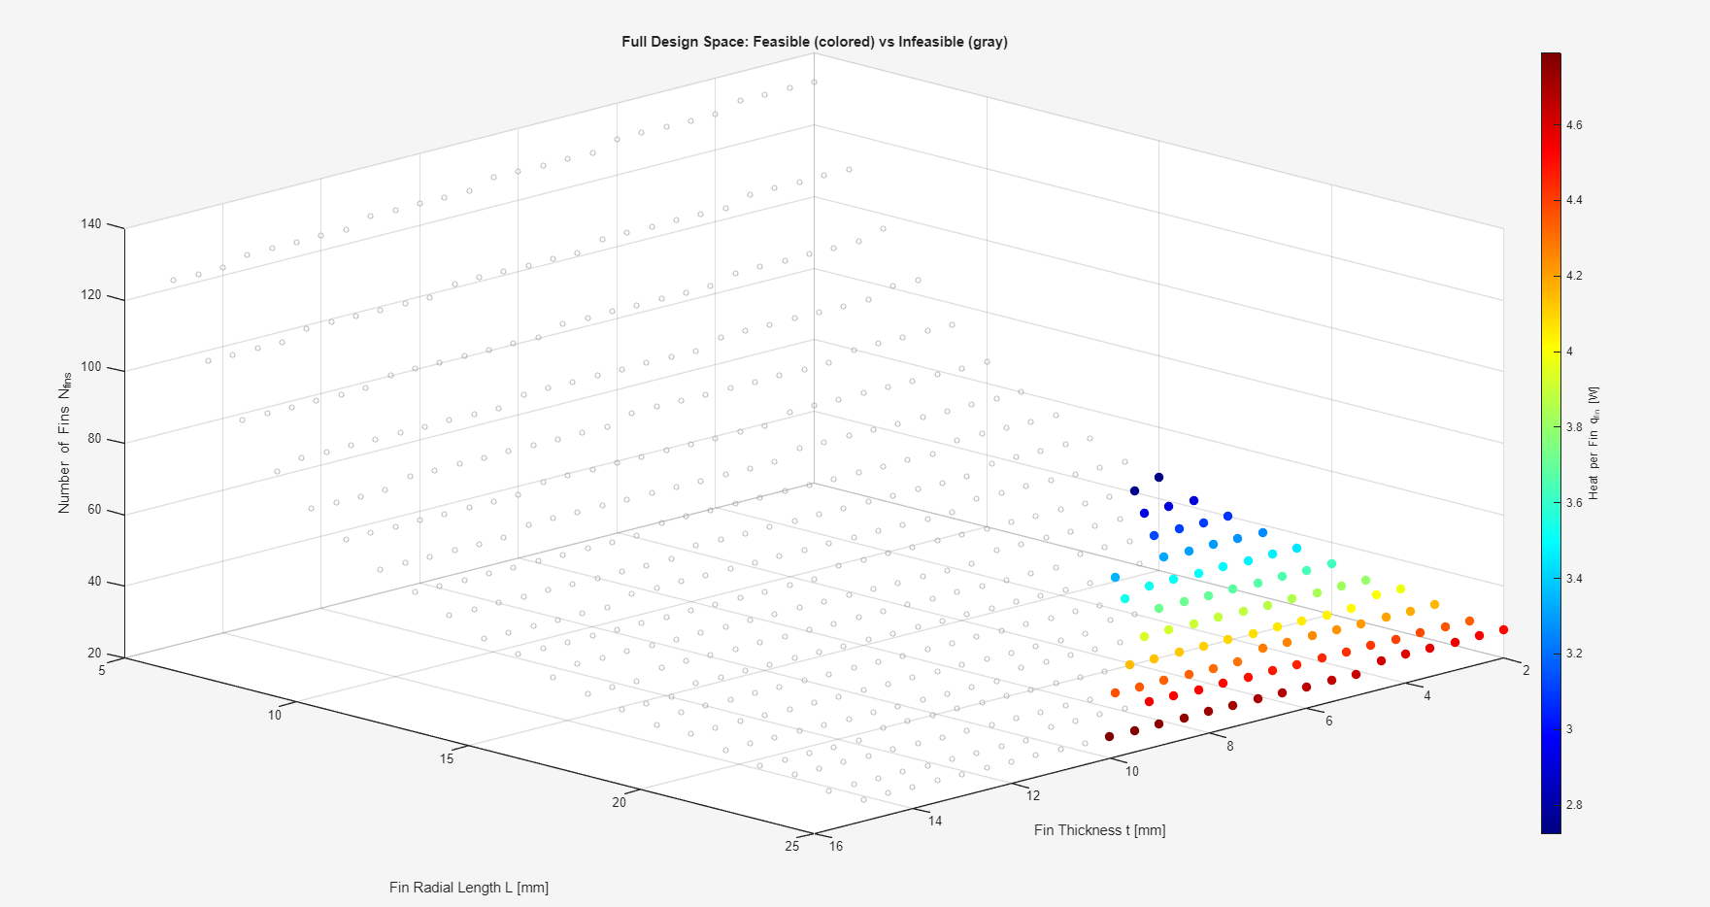

Problem 3
Problem Parameters
------------------
Motor Power P_motor = 2000 W
Motor Efficiency eta_motor = 0.94
Required Heat Removal q_Required = 120.00 W [= (1 - eta) * P_motor]
Base Temperature T_b = 80.0 C
Ambient Temperature T_inf = 20.0 C
Temperature Difference T_b-T_inf = 60.0 C
Fin Conductivity k_fin = 200.0 W/mK
Fin Width (motor axis) w = 0.1500 m (5.9055 in)
Motor Diameter D = 0.1500 m (5.9055 in)
Motor Circumference Pmax = 0.4712 m (18.5527 in)
Min Fin Spacing smin = 0.0080 m (0.3150 in)
Thickness Range t_range = [0.0020 : 0.0150] m
Length Range L_range = [0.0050 : 0.0250] m
Convection Coeff h_forced = 32.3959 W/m^2K
Total Feasible Designs = 499
Maximum q_fin (feasible designs) = 2.9505 W

Forced Convection Coefficient Calculation
------------------------------------------
Film Temperature T_f = 50.0 C
Free Stream Velocity U_inf = 10.00 m/s
Air Density rho_fluid = 1.1270 kg/m^3
Dynamic Viscosity mu_fluid = 1.9600e-05 Pa*s
Thermal Conductivity k_fluid = 0.0280 W/mK
Specific Heat cp_fluid = 1007.0 J/kgK
Reynolds Number Re_w = 8.625e+04
Prandtl Number Pr = 0.7049
Flow Regime = laminar (Re_w <= 5e5)
Nusselt Number Nu_w = 173.5495
Forced Convection h h_forced = 32.3959 W/m^2K

========================================================================
TOP 10 DESIGNS - Ranked by Descending q_fin
========================================================================
Rank t[m] t[in] L[m] L[in] N_fins %Perim eta_f% Space[m] q_fin[W]
------------------------------------------------------------------------------
1 0.0150 0.5906 0.0250 0.9843 8 25.46 99.51 0.0439 15.9571
2 0.0145 0.5709 0.0250 0.9843 8 24.62 99.49 0.0444 15.9063
3 0.0140 0.5512 0.0250 0.9843 8 23.77 99.48 0.0449 15.8553
4 0.0135 0.5315 0.0250 0.9843 8 22.92 99.46 0.0454 15.8042
5 0.0130 0.5118 0.0250 0.9843 8 22.07 99.44 0.0459 15.7528
6 0.0125 0.4921 0.0250 0.9843 8 21.22 99.42 0.0464 15.7013
7 0.0120 0.4724 0.0250 0.9843 8 20.37 99.40 0.0469 15.6495
8 0.0115 0.4528 0.0250 0.9843 8 19.52 99.37 0.0474 15.5974
9 0.0110 0.4331 0.0250 0.9843 8 18.67 99.35 0.0479 15.5450
10 0.0105 0.4134 0.0250 0.9843 8 17.83 99.32 0.0484 15.4922

========================================================================
BEST DESIGN SUMMARY - Rank 1 (Highest q_fin)
========================================================================
Fin Thickness t = 0.0150 m (0.5906 in)
Fin Length L = 0.0250 m (0.9843 in)
Number of Fins N_fins = 8
Optimality mL = 0.1219
Fin Efficiency eta_f = 99.51 %
Perimeter Used %Perim = 25.46 %
Fin Spacing Space = 0.0439 m (1.7285 in)
Heat per Fin q_fin = 15.9571 W
Total Heat q_total = 127.6566 W

